An operating system is a program that manages the computer hardware. Operating System is an interface between a user of a computer and the computer hardware.
A computer system can be divided into – the hardware, the operating system, the application programs and the users. The hardware consisting of CPU, memory and I/O devices provides the basic computing resources for the system. The application programs define the ways in which these resources are used to solve users’ computing problems.
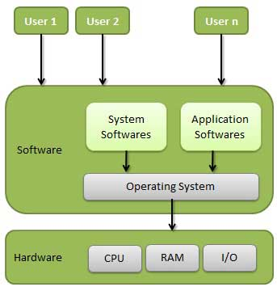
The operating system controls and co-ordinates the use of hardware among the various application programs for the various users.
User view of an Operating System: to maximize the work that the user is performing. Mostly for easy of use. The user sits at a terminal connected to a main frame & other users can access the same computer through other terminals.
To maximize resource utilization to assure that all available CPU time, memory and I/O are used efficiently. User shares resources such as networking and servers.
System view of an Operating System: the system point of view, OS can be viewed as resource allocator resources are – CPU time, memory space, file storage space, I/O devices etc. OS must decide how to allocate these resources to specific programs and users so that it can operate the computer system efficiently.
OS is of Resource manager. Resource management includes multiplexing resources in two ways - "in time" and "in space".
(i)When a resource is time multiplexed different programs or different users gets their turn to use that resource. Ex: Printer.
(ii)When a resource is space multiplexed instead of taking turns, the resource is shared among them, i.e. each one gets a part of the resource. Ex: Sharing main memory, hard disk etc.

OBJECTIVES OF AN OPERATING SYSTEM
- Convenience (Easy) - An operating system makes a computer more convenient to use.
- Efficiency - An operating system allows the computer system resources to be used in an efficient manner.
Ability to develop - An Operating System should be constructed in such a way as to allow effective development, testing, and introduction of new system functions without interfering with service.
- Evolution of Operating Systems or Types of Operating System:
- Serial Processing
The Serial Processing Operating Systems are those which Performs all the instructions into a Sequence Manner or the Instructions those are given by the user will be executed by using the FIFO Manner. Programmer interacted directly with the hardware & there was no Operating System. Machines run from a console with display lights and toggle switches, input device, and printer. Programs were in machine language and loaded via input devices. Error condition was indicated by lights. For the correct program, the output appeared on the printer. But the Main Problem is that a user doesn’t interact with the System while he is working on the System, means the user can’t be able to enter the data for Execution.

- Batch Operating System:
The users of batch operating system do not interact with the computer directly. Each user prepares his job on an off-line device like punch cards and submits it to the computer operator. To speed up processing, jobs with similar needs are batched together and run as a group. Thus, the programmers left their programs with the operator. The operator then sorts programs into batches with similar requirements.
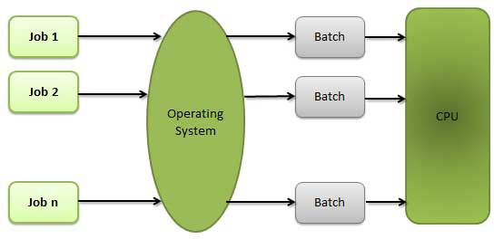

- Advantages o Batch System
- Move much of the work of the operator to the computer.
- Increased performance since it was possible for job to start as soon as the previous job finished.

- Disadvantages of Batch System
- Lack of interaction between the user and job.
- CPU is often idle, because the speeds of the mechanical I/O devices are slower than CPU.
- Difficult to provide the desired priority.
- Difficult to debug program.
- A job could enter an infinite loop

- Uniprogramming Systems:
• Processor must wait for I/O instruction to complete before proceeding
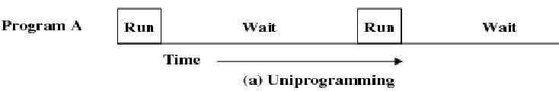
- Multi Programming Operating Systems:
Multiprogramming operating system allows more than one program to run concurrently. Multi programming increases CPU utilization by sending multiple jobs to CPU. OS keeps all jobs in memory that is job pool which contains all jobs that enter the system. OS picks and start to execute one of the jobs. The running job required some resources task, such as I/O operation to complete that time it wait. Then OS simply switches to execute another job. When that job needs to wait, CPU is switched to another job and so on. Multiprogramming is the first example where the operating system must make decisions for the users. All the jobs that enter the system are kept in the job pool. This pool consists of all processes residing on disk awaiting allocation of main memory. If several jobs are ready to run at the same time, the system must choose among them. Making this decision is CPU scheduling. Multi programmed systems provide an environment in which the various system resources are utilized effectively but they do not provide for user interaction with the computer system.
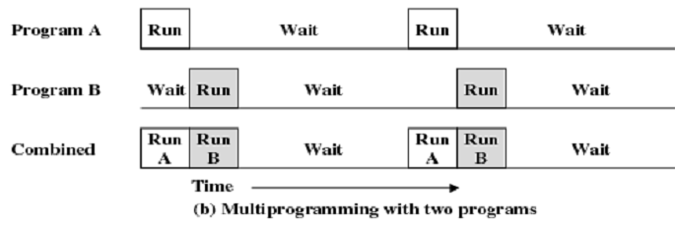
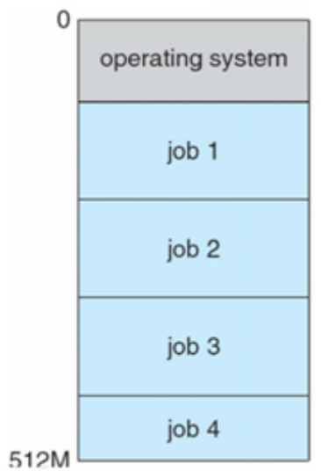
- Advantages
- High CPU utilization.
- It appears that many programs are allotted CPU almost simultaneously.

- Disadvantages
- CPU scheduling is requires.
- To accommodate many jobs in memory, memory management is required

Spooling

Spooling means simultaneous peripheral operations on line. Spooling refers to putting jobs in a buffer. Spooling is useful because device access data that different rates. The buffer provides a waiting station where data can rest while the slower device catches up.
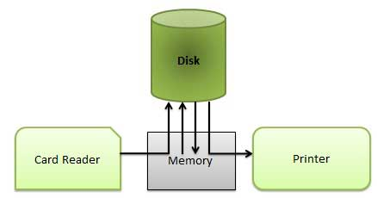
- Computer can perform I/O in parallel with computation, it becomes possible to have the computer read a punch of cards to a tape or disk and to write out on a tape printer while it was computing. This process is called spooling.
- The most common spooling application is print spooling. The documents are loaded into a buffer and the printer pulls them off the buffer at its own rate.
- Spooling is also used for processing data at remote sites. The CPU sends the data via communications path to a remote printer. Spooling overlaps the I/O of one job with the computation of other jobs.
- One difficulty with simple batch systems is that the computer still needs to read the punch of cards before it can begin to execute the job. This means that the CPU is idle during these relatively slow operations.

Advantage of Spooling
1. The spooling operation uses a disk as a very large buffer.
2. Spooling is capable of overlapping I/O operation for one job with processor operations for another job.

- Time Sharing Systems (Multitasking):
A time sharing system allows many users to share the computer resources simultaneously. Time sharing refers to the allocation of computer resources in time slots to several programs simultaneously. For example a mainframe computer that has many users logged on to it. Each user uses the resources of the mainframe -i.e. memory, CPU etc. The users feel that they are exclusive user of the CPU, even though this is not possible with one CPU i.e. shared among different users.
Time-sharing requires direct communication between the user and the system. A time shared system uses CPU scheduling and multiprogramming to provide each user with a small portion of a time-shared computer. It allows many users to share the computer resources simultaneously. As the system switches fast from one user to the other, a short time slot is given to each user for their executions.
The time sharing system provides the direct access to a large number of users where CPU time is divided among all the users on scheduled basis. The OS allocates a set of time to each user. When this time is expired, it passes control to the next user on the system. This short period of time during that a user gets CPU is known as a time slice or a quantum. The concept of time sharing system is shown in figure.
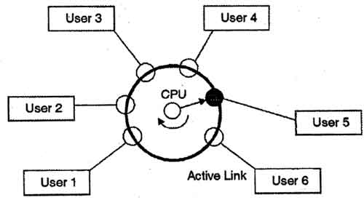
In figure the user 5 is active but user 1, user 2, user 3, and user 4 are in waiting state whereas user 6 is in ready status. As soon as the time slice of user 5 is completed, the control moves on to the next ready user i.e. user 6. In this state user 2, user 3, user 4, and user 5 are in waiting state and user 1 is in ready state. The process continues in the same way and so on.
The time-shared systems are more complex than the multi-programming systems. In time-shared systems multiple processes are managed simultaneously which requires an adequate management of main memory so that the processes can be swapped in or swapped out within a short time.
- Advantages
- Provide advantage of quick response.
- Avoids duplication of software.
- Reduces CPU idle time & increase CPU Utilization
- Disadvantages
- Problem of reliability.
- Problem security and integrity of user programs and data.
- Problem of data communication.

- Parallel Systems (Multiprocessor Systems or Tightly Coupled Systems) :
Multiprocessing: Generally a Computer has a Single Processor means a Computer have one CPU for Processing the instructions. But if we are Running multiple jobs, then this will decrease the Speed of CPU. For Increasing the Speed of Processing then we uses the Multiprocessing. In the Multi Processing there are two or More CPU in a Single Operating System if one CPU will fail, then other CPU is used for providing backup to the first CPU. With the help of Multi-processing, we can Execute Many Jobs at a Time. All the Operations are divided into the Number of CPU’s. if first CPU Completed his Work before the Second CPU, then the Work of Second CPU will be divided into the First and Second. These type of systems have more than one processor in close communication, sharing the computer bus, the clock, and sometimes the, memory and peripheral devices
• These types of systems are referred to as tightly coupled system
• Common Multiprocessor systems are:
- Symmetric multiprocessor (SMP)
- Each processor runs an identical copy of the operating system
- Many processor can run at once without performance deterioration
- Most modern operating systems support SMP
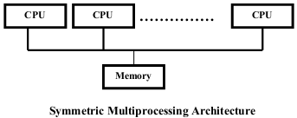
- Asymmetric multiprocessing
- Each processor is assigned a specific task; master processor schedules and allocated work to slave processors
- More common in extremely large systems
- Advantages of Parallel systems:
- Increased throughput
- By increasing the number of processors, we done more work in less time Memory
- Economy of scale (Economical)
- Can share peripherals, mass storage and power supplies
- Increase reliability
- Failure of one processor will not halt the system, only slow it down

- Distributed Systems (Loosely Coupled System):
A distributed operating system is an extension of the network operating system that supports higher levels of communication and combination of the machines on the network. In distributed Operating System model where distributed applications are running on multiple computers linked by communication lines. This system looks to its users like an ordinary centralized operating system but runs on multiple, independent CPU.
These systems are referred as loosely coupled systems where each processor has its own local memory and processors communicate with one another through various communication lines, such as high speed buses or telephone lines. By loosely coupled systems, such computers have no hardware connections at the CPU - memory bus level, but are connected by external interfaces that run under the control of software.
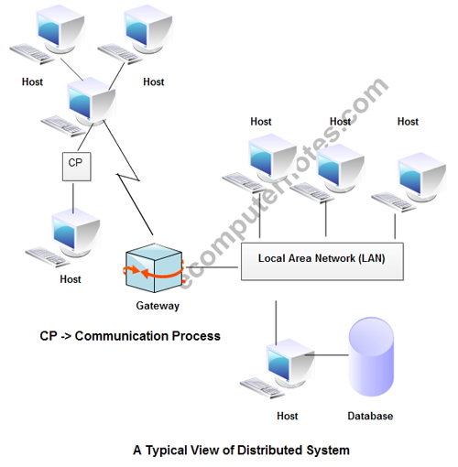
The Distributed OS involves a collection of independent computer systems, capable of communicating and cooperating with each other through a LAN / WAN. A Distributed OS provides a virtual machine abstraction to its users and wide sharing of resources like as computational capacity, I/O and files etc.
The structure shown in fig contains a set of individual computer systems and workstations connected via communication systems, but by this structure we cannot say it is a distributed system because it is the software, not the hardware, that determines whether a system is distributed or not.
- Advantages
- Resource sharing another.
- Speedup the exchange of data with one another via electronic mail.
- If one site fails in a distributed system, the remaining sites can continue operating.
- Better service to the customers.
- Reduction of the load on the host computer.
- Reduction of delays in data processing.

- Real Time Systems:
Real time Operating Systems are very fast and quick respondent systems. These systems are used in an environment where a large number of actions must be accepted and processed in a short time. Real time processing requires quick transaction and characterized by supplying immediate response. In real time operating system there is a little swapping of programs between primary and secondary memory. Most of the time, processes remain in primary memory in order to provide quick response, therefore, memory management in real time system is less demanding compared to other systems. It defined fixed time constraints system.
Often used as a control devices in a dedicated application such as controlling scientific experiments, medical imaging systems, industrial control systems, Airlines reservation system, Air traffic control system, Systems that provide immediate updating, Systems that provide up to the minute information on stock prices, Defense application systems like as RADAR and some display systems.
• Real time systems may be
- Hard Real Time
- Secondary storage limited or absent, data stored in short term memory or read only memory (ROM)
- Hard real-time systems guarantee that critical tasks complete on time.
- Conflicts with time sharing systems, not supported by general purpose
- Soft Real Time
- Limited utility in industrial control of robotics
- Soft real time systems are less restrictive. Critical real-time task gets priority over other tasks and retains the priority until it completes.
- Useful in applications (multimedia, virtual reality) requiring advanced operating system features

Single-user, single task - this operating system is designed to manage the computer so that one user can effectively do one thing at a time. The Palm OS for Palm handheld computers is a good example of a modern single-user, single-task operating system.

Single-user, multi-tasking - This is the type of operating system most people use on their desktop and laptop computers today. Microsoft's Windows and Apple's MacOS platforms are both examples of operating systems that will let a single user have several programs in operation at the same time. For example, it's entirely possible for a Windows user to be writing a note in a word processor while downloading a file from the Internet while printing the text of an e-mail message.

Multi-user - A multi-user operating system allows many different users to take advantage of the computer's resources simultaneously. The operating system must make sure that the requirements of the various users are balanced, and that each of the programs they are using has sufficient and separate resources so that a problem with one user doesn't affect the entire community of users. Unix, VMS and mainframe operating systems, such as MVS, are examples of multi-user operating systems.

Operating System services
Operating system provides an environment for the execution of programs. It provides certain services to programs and to the users of those programs.
Services that provide user-interfaces to OS
- Program execution - load program into memory and run it.
- I/O Operations - users cannot execute I/O operations directly.
- File System Manipulation - read, write, create, delete files.
- Communications – inter process and intersystem.
- Error Detection - in hardware, I/O devices, user programs.
Services for providing efficient system operation
- Resource Allocation - for simultaneously executing jobs
- Accounting - for account billing and usage statistics
- Protection - ensure access to system resources is controlled

- User interface: All OS have a user interface(UI).Interfaces are of three types-
- Command Line Interface: uses text commands and a method for entering them
- Batch interface: commands and directives to control those commands are entered into files and those files are executed.
- Graphical user interface: This is a window system with a pointing device to direct I/O, choose from menus and make selections and a keyboard to enter text.

- Program execution: System must be able to load a program into memory and run that program. The program must be able to end its execution either normally or abnormally.

- I/O operations: A running program may require I/O which may involve a file or an I/O device. For efficiency and protection, users cannot control I/O devices directly.

- File system manipulation: Programs need to read and write files and directories. They also need to create and delete them by name, search for a given file, and list file information.

- Communications: One process might need to exchange information with another process. Such communication may occur between processes that are executing on the same computer or between processes that are executing on different computer systems tied together by a computer network. Communications may be implemented via shared memory or through message passing.

- Error detection: OS needs to be constantly aware of possible errors. Errors may occur in the CPU and memory hardware, in I/O devices and in the user program. For each type of error, OS takes appropriate action to ensure correct and consistent computing.

- Resource allocation: When there are multiple users or multiple jobs running at the same time, resources must be allocated to each of them. Different types of resources such as CPU cycles, main memory and file storage are managed by the operating system OS manages all kind of resources using schedulers.CPU scheduling algorithms are used for better utilization of CPU

- Accounting: Keeping track of which users use how much and what kinds of computer resources.

- Protection and security: Controlling the use of information stored in a multiuser or networked computer system. Protection involves ensuring that all access to system resources is controlled. Security starts with requiring each user to authenticate him or herself to the system by means of password and to gain access to system resources.

- System Components:

Process Management

A process is a program in execution. A process needs resources i.e CPU time, memory, files, and I/O devices, to complete its task. These resources are either given to the process when it is created, may be allocated to it when it is running. Program is a passive entity, because contents of a file stored on disk and Process is an active entity, with a program counter specifying the next instruction to execute. The execution of a process must be sequential.
- Creating and deleting both user and system processes.
- Suspending and resuming processes.
- Providing mechanisms for process synchronization.
- Providing mechanisms for process communication.
- Providing mechanisms for deadlock handling.

Main Memory Management

Main memory is a large array of words or bytes each with its own address. Main memory is a storage area of fast accessible data shared by the CPU and I/O devices. Many different memory management schemes are available and the effectiveness of the different algorithms depends on the particular situation.
- Keeping track of which parts of memory are currently being used and by whom.
- Deciding which processes are to be loaded into memory when memory space becomes available.
- Allocating and de allocating memory space as needed.

File Management

Computers can Store information on different types of physical media each having its own characteristics and physical organization. A file is a collection of related information defined by its creator. It represents programs and data. The OS implements the abstract concept of a file by managing mass storage media, such as disks & tapes, and the devices that control them.
- Creating and deleting files
- Creating and deleting directories
- Supporting primitives for manipulating files and directories
- Mapping files onto secondary storage
- Backing up files on stable (nonvolatile) storage media.

I/O –System Management

One of the purposes of an operating system is to hide the specific hardware devices form the user. Operating System manages the communication between user and device drivers. The I/O subsystem consists of

- A memory management component that includes buffering, caching and spooling.
- A general device – driver interface.
- Drivers for specific hardware devices
- Read or write operation with any file or any specific I/O device.
- Program may require any I/O device while running.
- Operating system provides the access to the required I/O device when required.

Secondary storage management

The main purpose of a computer system is to execute programs. These programs must be in main memory at the execution time. A main memory is too small and volatile; the computer system use secondary storage to back up data.
- Free – space management
- Storage allocation
- Disk scheduling.

Communication

distributed systems which are a collection of processors that do not share memory, peripheral devices, or a clock, operating system manages communications between processes. Multiple processes with one another through communication lines in the network.

OS handles routing and connection strategies and the problems of contention and security. Access to a shared resource allows computation speedup, increased functionality, increased data availability, and enhanced reliability. Operating systems usually generalize network access as a form of file access, with the details of networking being contained in the network interface's device driver.
- Two processes often require data to be transferred between them.
- The both processes can be on the one computer or on different computer but are connected through computer network.
- Communication may be implemented by two methods either by Shared Memory or by Message Passing.

Protection System

If a computer system has multiple users and allows the concurrent execution of multiple processes, then the various processes must be protected from one another’s activities. Protection is any mechanism for controlling the access of programs, processes, or users to the resources defined by a computer system. Protection can improve reliability by detecting latent errors at the interfaces between component subsystems.
- OS ensures that all access to system resources is controlled.
- OS ensures that external I/O devices are protected from invalid access attempts.
- OS provides authentication feature for each user by means of a password.

Command-Interpreter System

A most important systems program for an operating system is the command interpreter which is the interface between the user and the operating system. Some of the operating systems include the command interpreter in the kernel. A program that reads and interprets control statements is executed automatically. Sometimes called control –card interpreter or command- line interpreter or shell. Its function is simple: To get the next command statement and execute it.

The command statements themselves deal with process creation and management, I/O handling, secondary-storage management, main-memory management, file-system access, protection, and networking.

- System Calls

System calls provide the interface between a running program and the operating system. They are generally available as assembly-language instructions. 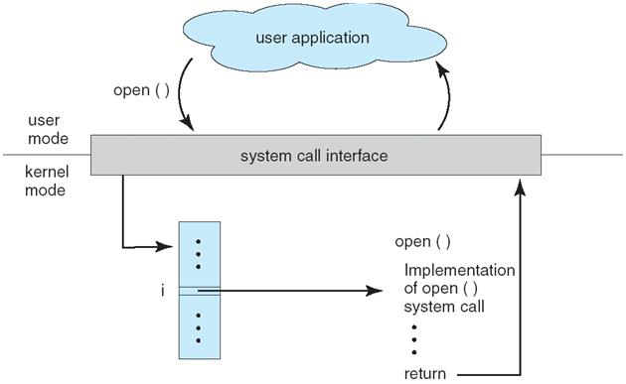

Three general methods are used to pass parameters between a running program and the OS :
- Pass parameters in registers
- Store the parameters in a table in memory, and the table address is passed as a parameter in a register
- Push(store) the parameters onto the stack by the program, and pop-off the stack by operating system

Different system calls are

Process control
- end, abort
- load, execute
- create process, terminate process
- get process attributes, set process attributes
- wait for time
- wait event, signal event
- allocate and free memory

File management
- create file, delete file
- open, close
- read, write, reposition
- get file attributes, set file attributes

Device management
- request device, release device
- read, write, reposition
- get device attributes, set device attributes
- logically attach or detach devices

Information maintenance
- get time or date, set time or date
- get system data, set system data
- get process, file, or device attributes
- set process, file, or device attributes

- Communications

There are two common models for communication

1. Message passing

2. Shared memory

In message passing model, information is exchanged through an interprocess – communication facility provided by the OS. Before communication can take place, a condition must be opened. The name of the other communicator must be known be it another process on the same CPU /Process on another computer connected by a communications network.

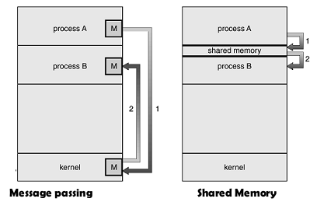

In shared memory, processes use map memory system calls to gain access to regions of memory owned other processes. They may then exchange information by reading and writing data in the shared area. Message passing is useful when smaller numbers of data need to be exchanged, because no conflicts need to be avoided. It is also easier to implement than is shared memory for inter-computer communication. Shared memory allows maximum speed and convenience of communication, as it can be done at memory speeds when within a computer.
- create, delete communication connection
- send, receive messages
- transfer status information
- attach or detach remote devices

- Monolithic approach:
The components of monolithic operating system are organized at random and any module. It can call any other module without any reservation. Applications in monolithic OS are separated from the operating system itself & OS code runs in a restricted processor mode (kernel mode) with access to system data and to the hardware. Applications run in a non- restricted processor mode (user mode), with a limited set of interfaces available and with limited access to system data. The monolithic operating system structure with separate user and kernel processor mode
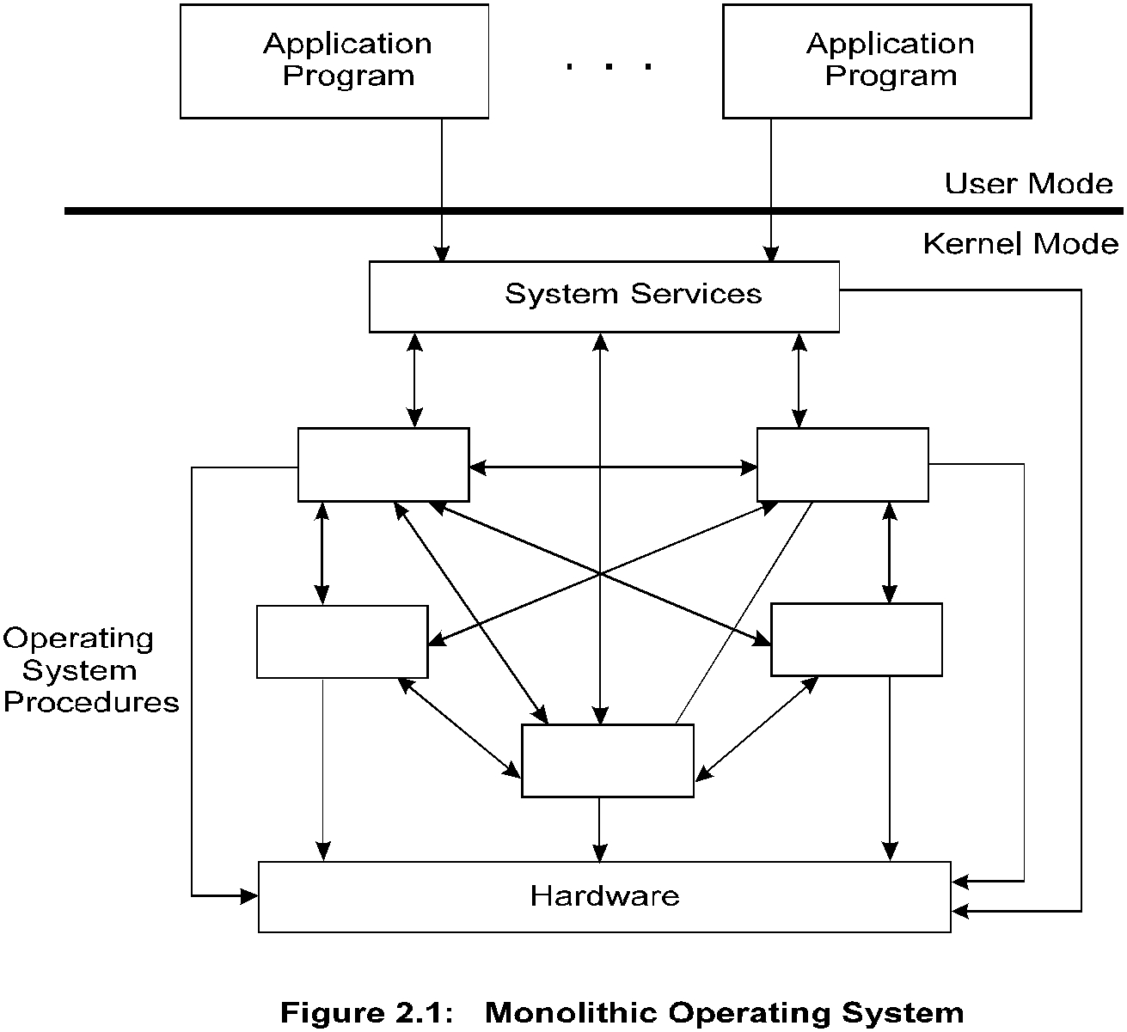
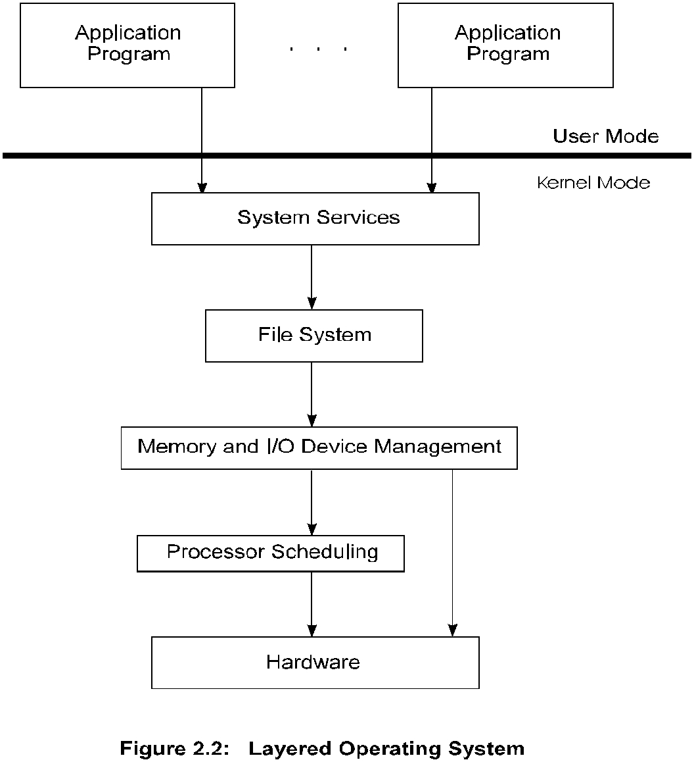

A collection of procedures in a single object/executable file. No information hiding. Not divided into modules. Interfaces and levels of functionality are not well separated. Limited by its hardware, Victim of its own success. To provide the most functionality in the least space. When a user-mode program calls a system service, the processor traps the call and then switches the calling thread to kernel mode. Completion of system service switches the thread back to the user mode, by the operating system and allows the caller to continue.
The monolithic structure does not enforce data hiding in the operating system. It delivers better application performance, but extending such a system can be difficult work because modifying a procedure can introduce bugs in seemingly unrelated parts of the system. Example Systems: CP/M and MS-DOS

- Layered Structure:
Most modern operating system organizes their components into a number of layers (levels), each built on top of lower layers. The bottom layer (layer o) is the hardware, and the highest layer (layer n) is the user interface. The number of in-between layers and their contents vary from one operating system to another. The main advantage of the layered approach is modularity. The layers are selected such that each layer uses the functions and services provided by its immediate lower layer. This approach greatly simplifies the design and implementation of the system because each layer is implemented using only those operations provided by its immediate lower level layer.
The operating system is divided into a number of layers (levels),each built on top of lower layers, The bottom layer (layer 0), is the hardware; the highest (layer N) is the user interface, With modularity, layers are selected such that each uses functions (operations) and services of only lower-level layers.

- Virtual Machine:
A virtual machine takes the layered approach to its logical conclusion. It treats hardware and the operating system (kernel) as still they were all hardware. A virtual machine provides an interface identical to the underlying bare hardware. The operating system creates the illusion of multiple processes, each executing on its own processor with its own (virtual) memory. The resources of the physical computer are shared to create the virtual machines.
• CPU scheduling can create the appearance that users have their own processor
• Spooling and a file system can provide virtual card readers and virtual line printers
• A normal user time-sharing terminal serves as the virtual machine operator’s console
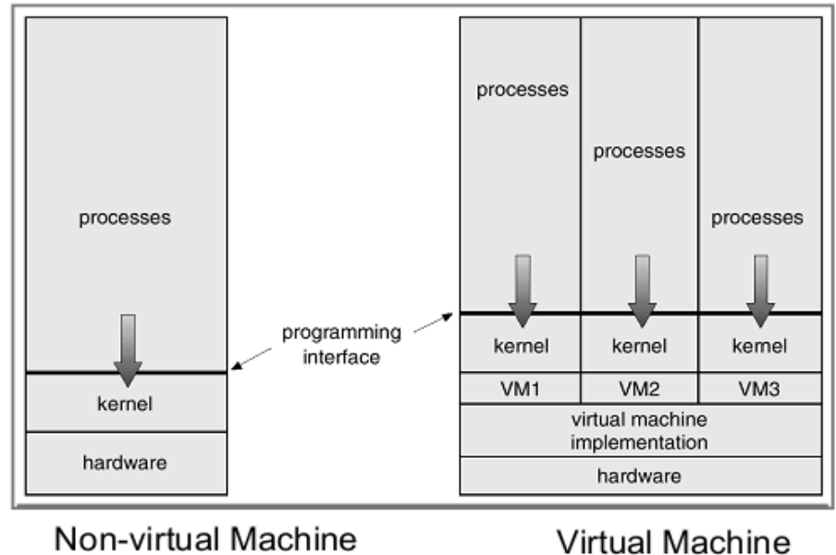
The virtual-machine concept provides complete protection of system resources since each virtual machine is isolated from all other virtual machines. This isolation, permits no direct sharing of resources. A virtual-machine system is a perfect vehicle for operating-systems research and development. System development is done on the virtual machine, instead of on a physical machine and so does not disrupt normal system operation. The virtual machine concept is difficult to implement due to the effort required to provide an exact duplicate to the underlying machine.

- Operating-System Design and Implementation
- Problems faced in designing and implementing an operating system
- Design and Implementation of OS not “solvable”, but some approaches have proven successful
- Internal structure of different Operating Systems can vary widely
- Start by defining goals and specifications
- Affected by choice of hardware, type of system

- User goals and System goals
User goals –operating system should be convenient to use, easy to learn, reliable, safe, & fast
System goals –operating system should be easy to design, implement, and maintain, as well as
flexible, reliable, error-free, and efficient
- Important principle to separate
- Policy: What will be done?
- Mechanism: How to do it?
- Mechanisms determine how to do something, policies decide what will be done
- The separation of policy from mechanism is a very important principle, it allows maximum flexibility if policy decisions are to be changed later

Design Goals
Firstly define goals and specification. E.g. Convenience, reliability, speed, flexibility, efficiency.

Mechanisms and Policies
- Mechanisms determine how to do something
- Policies determine what will be done
- Separating policy and mechanism is important for flexibility
- Policies change over time; mechanisms should be general

- Implementation
- OS's are nowadays written in higher-level languages like C / C++
- Advantages of higher-level languages: faster development and the OS is easier to port (i.e. move to other hardware)
- Disadvantages of higher-level languages: reduced speed and increased storage requirements
Questions

Q. 1 Explain various operating system services?

Q. 2 Define Spooling? Describe Spooling process?

Q. 3 Explain Virtual Machine?

Q.4 what are the O.S components? Explain it.

Q.5 what do you mean by an Operating System? What are the main functions of an OS?

Q6. Discuss a Brief comparison among Batch Processing, Multiprogramming, and Time

Sharing, Real Time and Distributed Operating System.

Q7. Explain System Implementation & Design.

Q8. What do you mean by Layered approach of Operating system structure? Give an example where it is implemented.

Question Banks
Q.1) Explain real time operating system in brief.
Q.2) Distinguish between Multitasking, Multiprogramming & Multiprocessor System.
Q.3) What is system calls? Explain various system calls.
Q.4) Explain different types of services provided by operating system.
Q.5) What are the main advantages of multiprogramming.
Q.6) What are the main difficulties in writing an operating system for a real time environment?
Q.7) Explain the term “degree of multiprogramming”.
Q.8) Define the essential properties of the following types of operating systems:
a) Batch b) Time sharing c) Real time d) Distributed
Q.9) How does the evolution of OS begin with batch processing system?
Q.10) What is resident monitor? How it supports in OS?
Q.11) Give the difference between monitor mode and user mode.
Q.12) Explain in detail about real time and distributed systems.
Q.13) How does the distinction between monitor mode and user mode functions as a rudimentary form of protection system?
Q.14) Describe the difference between symmetric and asymmetric multiprocessing
Q.15) Explain the batch operating system in brief.

Q.16) Discuss the various issues related to the system program.

Q17) Discuss five major activities of an operating system in regard to process management.

Q18) Discuss three major activities of an operating system with respect to file management

Q19) How virtual machines are useful in designing a system?

Q20) Why system calls are important in an interactive system?

Q21) Explain how protection is provided for the hardware resources by the operating system.

